Still Missing at the Top: Women and Senior Leadership in the International Financial Institutions

Eeshani Kandpal and Brian Webster

In 2023, a Center for Global Development working paper documented how women remained strikingly underrepresented in senior leadership roles across the international financial institutions (IFIs), despite decades of stated commitments to gender equality. This blog revisits and updates that analysis using newly compiled data through 2025, drawing on expanded and revised leadership rosters across major multilateral development banks and international financial institutions. The updated figures show that while women’s representation has improved in some institutions, progress remains uneven and fragile, with persistent gaps at the very top of global economic decision-making, and strikingly, even some evidence of backsliding.

Measuring who leads
Our analysis focuses on senior leadership, defined as the most influential positions shaping strategy and resource allocation: presidents, managing directors, vice presidents, and equivalent roles. Over the course of November and December 2025, we gathered publicly available information from industry reports, databases, and the IFIs’ websites, relying on leadership pages, senior employee profiles, and published organizational flow charts. We requested data directly from the IFIs as well and incorporated what was shared with us. We then combined this information with the data gathered as part of our original working paper, using our best judgement when aligning specific managerial levels.
The institutions covered here are the same seven as in our earlier work: the World Bank, International Monetary Fund (IMF), Asian Development Bank (ADB), Inter-American Development Bank (IDB), European Investment Bank (EIB), the African Development Bank (AfDB), and the European Bank for Reconstruction and Development (EBRD).
Because leadership teams are small—often fewer than ten people—shares can fluctuate sharply year to year. Still, taken together, long-run trends are informative. Here’s what we find.
Not a single IFI at parity
As of December 2025, not one of the IFIs in our sample was at gender parity in its top management cadres. The IMF had the lowest share of women, at 23.8 percent, and the IDB (44.6 percent) and EIB (44.4 percent). The EBRD (42.5 percent) was the only other IFI with over forty percent women in senior management.

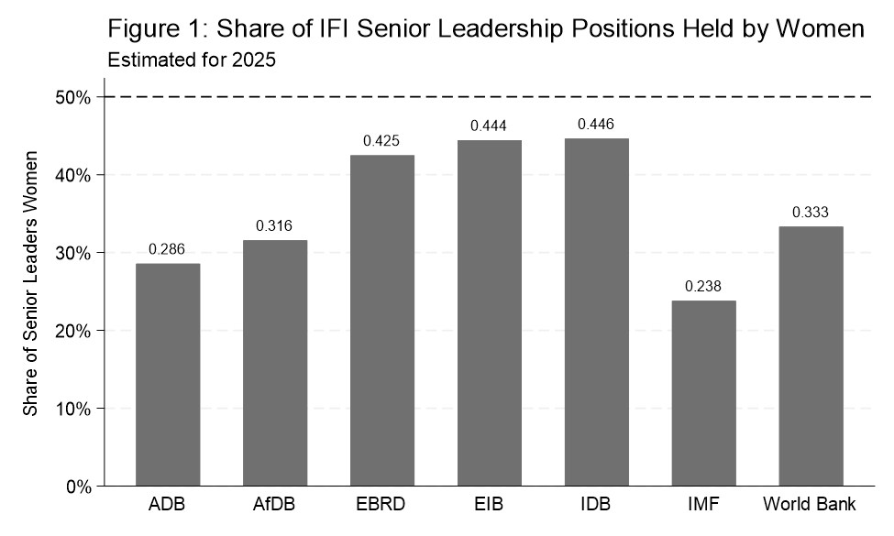

The World Bank: years of progress but recent backsliding
Coding the World Bank’s publicly posted leadership data posed a bit of a challenge. On the one hand, the World Bank’s website lists twelve people under “World Bank Group Leadership”, but it goes on to list several dozen other positions within its broader “Leadership Group.” We choose to define senior leadership as the twelve listed under “World Bank Group Leadership” (see Figure 1 above). For a broader measure of leadership (and consistent with our earlier working paper), however, we use an additional measure that includes senior leaders at the level of Vice President– this adds 35 total positions, based on the World Bank’s website.
The updated data for the World Bank underscore both meaningful progress and recent backsliding. As Figure 2 below shows, the share of senior leadership positions held by women rose steadily from roughly 20 percent in the early 2000s to the mid-40s by the early 2010s, reaching a first peak in the earlier 2010s and then a second peak just below parity in the late 2010s. This period marked the strongest sustained gains in women’s representation at the top of the institution. Since then, however, progress has proven fragile. Women’s share has declined sharply in the most recent years, falling from 37.5 percent in 2023 to around 30 percent in 2025. The overall trajectory highlights a central theme of this update: while the World Bank has quite recently demonstrated that parity in senior leadership is an achievable target, previous gains have not been institutionalized, leaving gender balance at the top highly sensitive to top leadership turnover rather than locked in by durable norms or appointment practices.
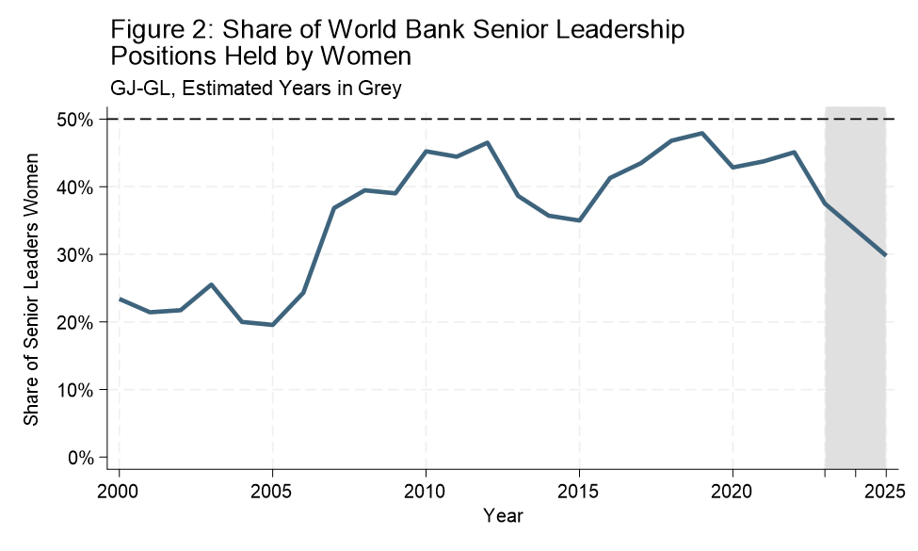
In part, part of the bottleneck may be the “waterfall” that we documented in earlier CGD research (Figure 3 below) from parity in early technocratic grades down to only about 30-40% representation in management and leadership. This waterfall is not unique to the WB: institutions are increasingly able to promote women into senior roles, but far fewer make it into the very top tier where ultimate authority resides. And this discrepancy is important: managers and directors may influence implementation, but it is the presidents and vice presidents who shape institutional priorities, budget allocations, and responses to crises.
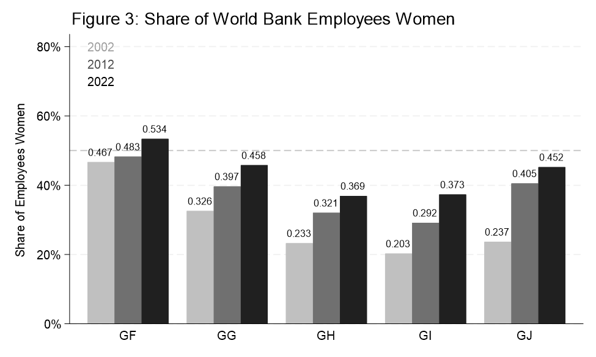
Source: Kandpal, Webster, and Kenny (2023). “Missing Figures” CGD.

The IMF: sharp downturn

The IMF's numbers show that, at 23.8% women in senior leadership as of December 2025, it has the lowest share of any institution in our sample— and the historical trend shows that despite periodic improvements, women's representation at the top of the Fund has remained consistently and persistently low. This matters disproportionately because of the IMF's reach. The Fund's surveillance, program design, and Article IV consultations shape fiscal space, social spending, and macroeconomic adjustment across the globe—decisions with well-documented gendered consequences. The IMF has itself acknowledged this: its 2022 gender mainstreaming strategy explicitly recognizes that macroeconomic adjustment can disproportionately burden women, and that fiscal and monetary policies must be designed with gender outcomes in mind. Yet the people making those calls remain overwhelmingly male.
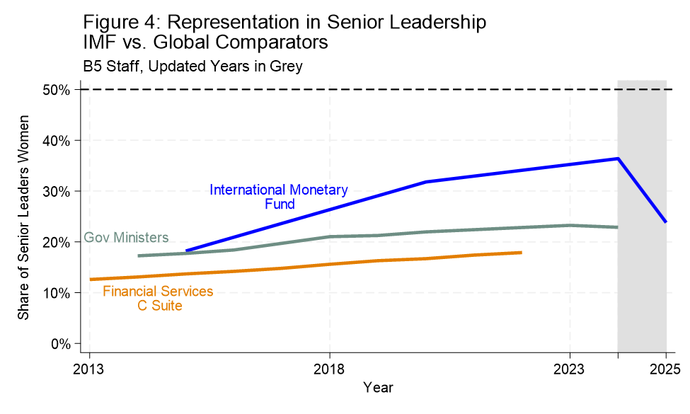

Mixed trajectories but signs of progress across several development banks
At the IDB, women’s representation in senior leadership has increased over time– not quite linearly, but certainly in a sustained manner. The picture looks even more encouraging when comparators are included, but we note that, even here, parity remains elusive.
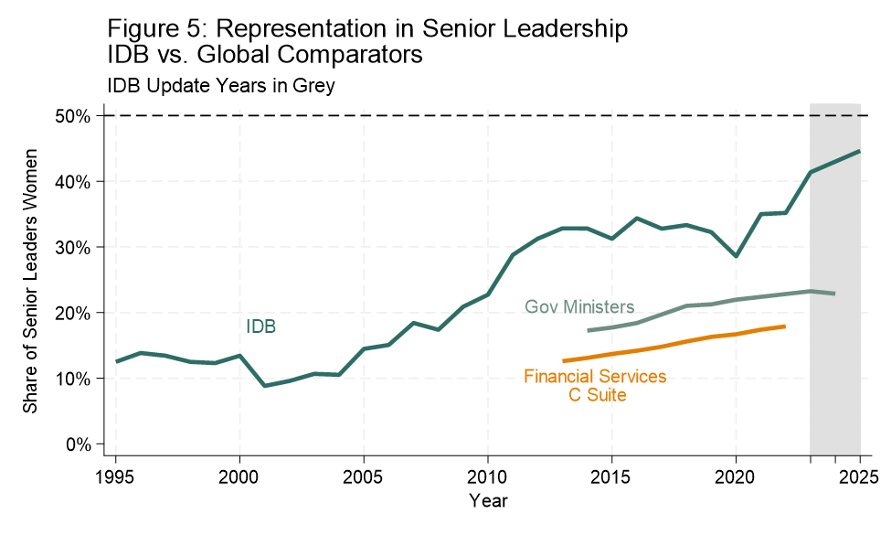
The ADB illustrates another challenge: small sample sizes. With leadership teams that rarely exceed five or six individuals, a single appointment or departure can dramatically change the headline number. This volatility complicates interpretation, but the underlying pattern remains clear—women are still underrepresented at the very top.

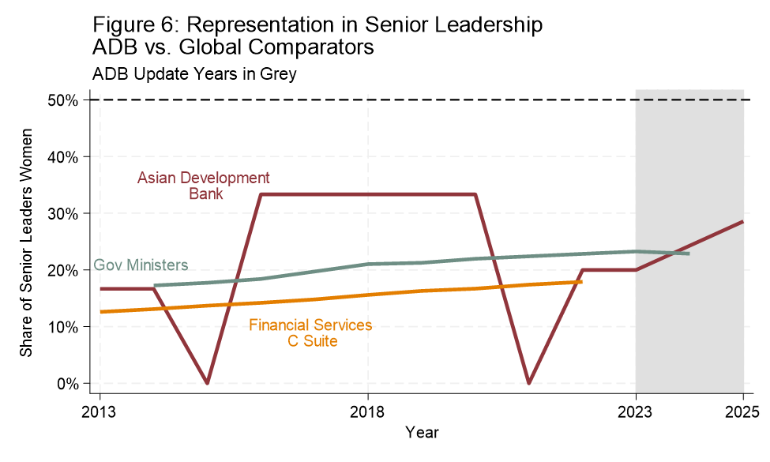
The EBRD presents one of the more encouraging trajectories in our sample, though progress here too remains incomplete and sensitive to leadership cycles. As of December 2025, the EBRD stood at 42.5% women in senior management, one of three institutions in our sample above 40%. This is notable given the EBRD's own recent strategic commitments: under its previous leadership cycle, the institution drove an institutional strategy explicitly centered on climate, inclusion, and digital solutions, and women in senior roles were central to shaping that agenda. The EBRD's relative performance is a reminder that near-parity is achievable–but that sustaining it requires embedding gender criteria into appointment practices rather than relying on the priorities of any individual leadership cohort.
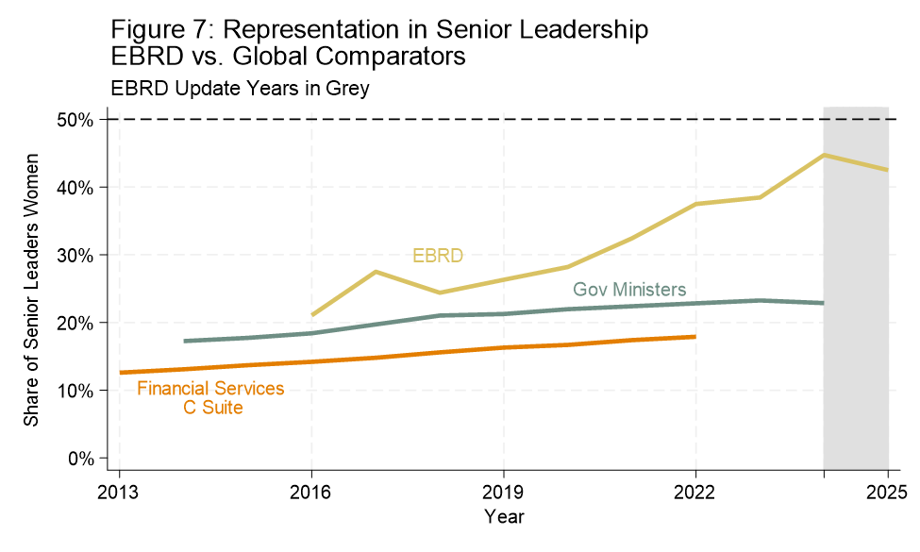

The EIB presents a somewhat brighter story in recent years, particularly when examining leadership over presidential and vice-presidential tenures. Compared with some peers, the EIB has moved closer to gender balance, especially when senior managers are included alongside top executives. Still, even here, women’s presence remains sensitive to leadership cycles rather than firmly institutionalized.
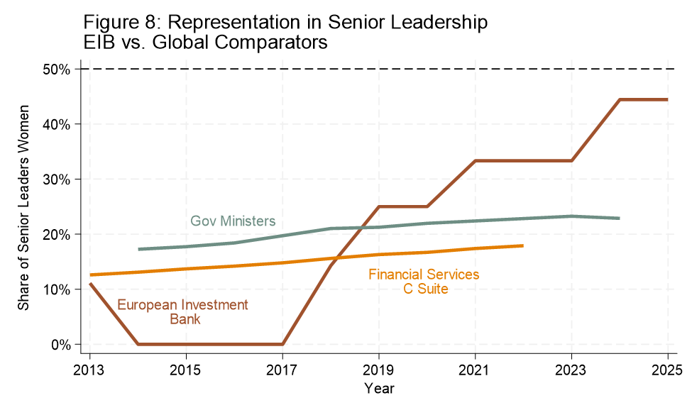
Note: Figure 8 did not appear in the original working paper.

Why gender parity in senior IFI leadership matters
We began with a data problem: women remain underrepresented at the top of every major IFI, and progress has been uneven, fragile, and in some cases reversed. But the stakes of this finding extend far beyond institutional aesthetics or organizational fairness. Two decades of rigorous empirical research shows that who holds senior leadership in the IFIs is a consequential lever for advancing women's economic and political leadership–and for IFI effectiveness–in borrowing countries.
For instance, a study using biographical data on thousands of World Bank task team leaders combined with the Bank's project-level Gender Mainstreaming Index finds that deeper implementation of gender mainstreaming–integrating gender across project design, activities, and monitoring, rather than checking a box to clear the approval threshold–is significantly more likely when women staff supervise projects, hold positions of authority, and are more represented as coworkers. The mechanism is institutional: the Bank's deeply embedded "approval culture" means that staff identities and values crucially determine day-to-day implementation decisions, and more than 90% of Bank staff see project approval as very or extremely important for their career success, making it decisive whether those in authority treat gender as a genuine priority or a compliance exercise. When the World Bank's senior women's share falls from near-parity to 30 percent, as it has in recent years, that is not an internal HR problem. It is a disconcerting sign that the quality of gender integration across hundreds of lending operations in dozens of countries is likely declining with it.
The IFI-specific finding sits within a broader and well-established literature on what female leadership actually changes. The foundational evidence comes from Chattopadhyay and Duflo's study of Indian village councils, which showed that women leaders invested more in infrastructure directly relevant to women's needs–water, roads, fuel–while men prioritized male-identified goods, establishing the core premise that the gender of decision-makers substantively shapes resource allocation. Another seminal study found that in villages assigned a female leader for two election cycles, the gender gap in career aspirations closed by 25% in parents and 32% in adolescents, educational attainment gaps were erased, and girls spent less time on household chores, with no evidence of labor market changes, suggesting the mechanism was primarily role modeling. More recent cross-national work confirms the pattern across a range of countries: women's representation in legislatures and cabinet positions correlates with greater legal rights and protections for women affecting their economic participation, with numerous qualitative and quantitative studies providing evidence that female officials substantively represent women's interests.
So, the gender gap in leadership that we document here is not just a problem inside these institutions. It is a problem that propagates outward, at scale.
And last but not the least, the IFIs routinely advise borrowing countries on governance, inclusion, and institutional reform. Persistent gender gaps at the top undermine credibility when these same institutions advocate for equality elsewhere.

What would real progress look like?
The data suggest three lessons for IFIs serious about change.
First, pipelines are necessary but not sufficient. Our earlier research has shown that qualified women are present in equal numbers in the entry technical grades. The barrier lies in promotion to the very top.
Second, appointments matter more than commitments. These data show how quickly gender balance can shift dramatically with each institutional leadership transition. Embedding gender criteria into selection processes—not just internal promotions—would reduce backsliding.
Third, transparency is not a “nice to have”. For publicly financed institutions, transparency is mission critical. The shareholders and governors of these institutions must demand such transparency and accountability. We cannot allow these institutions to sweep such stagnation or backsliding under the rug.
The data we present are a progress report. They show improvement in some institutions, backsliding in others, and not one institution at parity. But they are also a map of leverage–of the places where closing a gap inside a Washington or Brussels headquarters produces cascading changes in the offices of finance ministers, in the aspirations of girls, and in the lives of women thousands of miles away.

